**Job Input**

Stand alone jenkins was installed in drcloude

Plugins installed:

SSH Credentials

SSH Agent

Build Name and setter

Ssh setup for deploytoQA job - <https://linuxtechlab.com/how-to-easily-add-ssh-credentials-on-jenkins-server/>

Create keys on QA server - cat pub key to authorized_keys file on QA server - copy Private key to jenkins credentials which is used in job

# **bitbucket-drcloude**

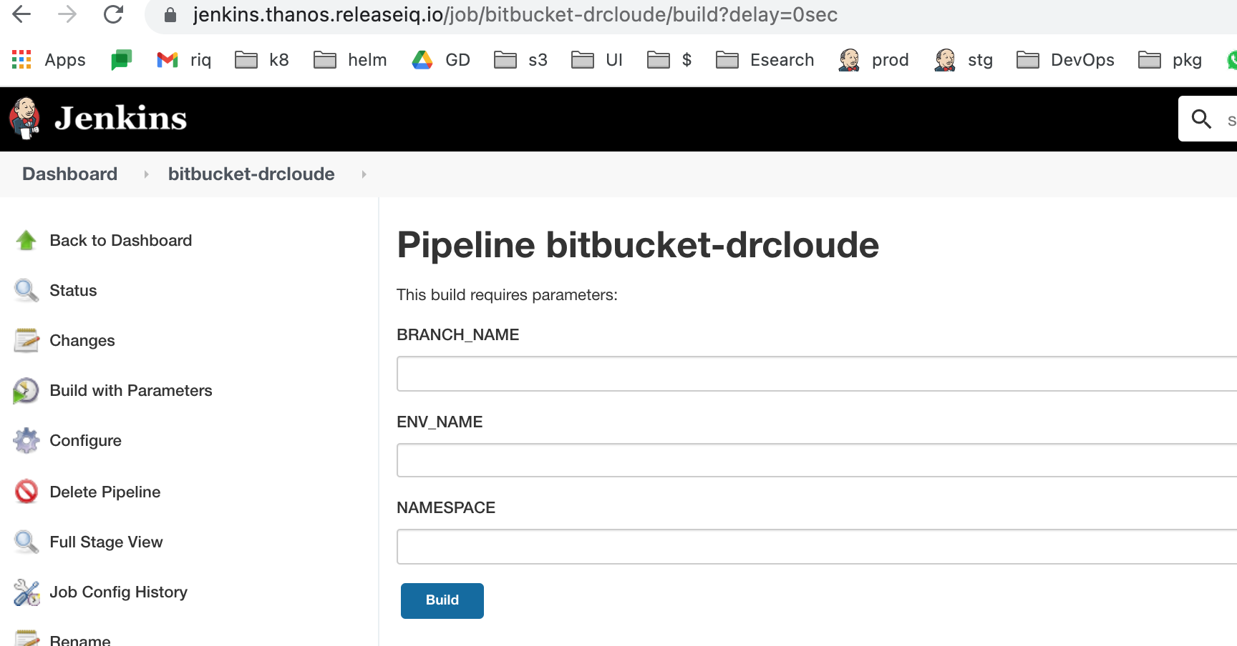

**bitbucket-drcloude-merge**

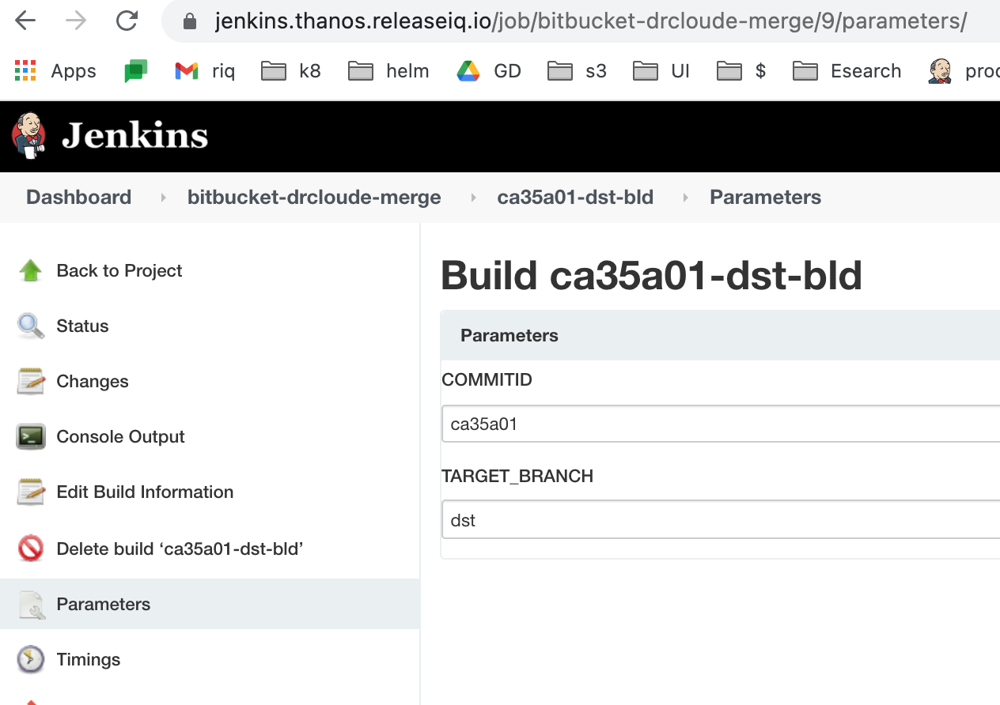

**drcloude-deploy-to-qa**

